

Database Systems
( Course Code: CSC270 )

Name: Muhammad Abdullah
Roll No # FA24-BSE-042
Instructor Name: Dr Rubina Adnan

Lab Assignment# 1
LAB TASK 1:
Write a SQL statement that displays the last_name, job_id, hire_date, and employee_id for each employee, with the employee_id appearing first. Rename HIRE_DATE column as STARTDATE.
Output:
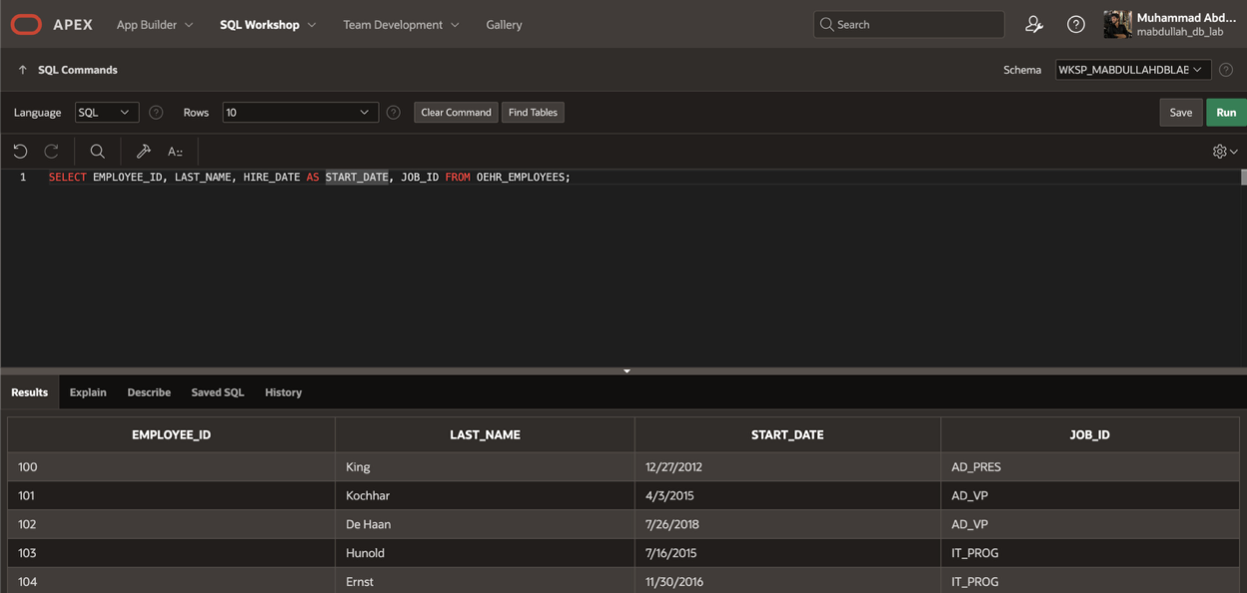
LAB TASK 2:
Write a SQL statement that displays the last_name concatenated with the job_id (separated by a command space) of all the employees and name the columns as Employee and Title.
Output:
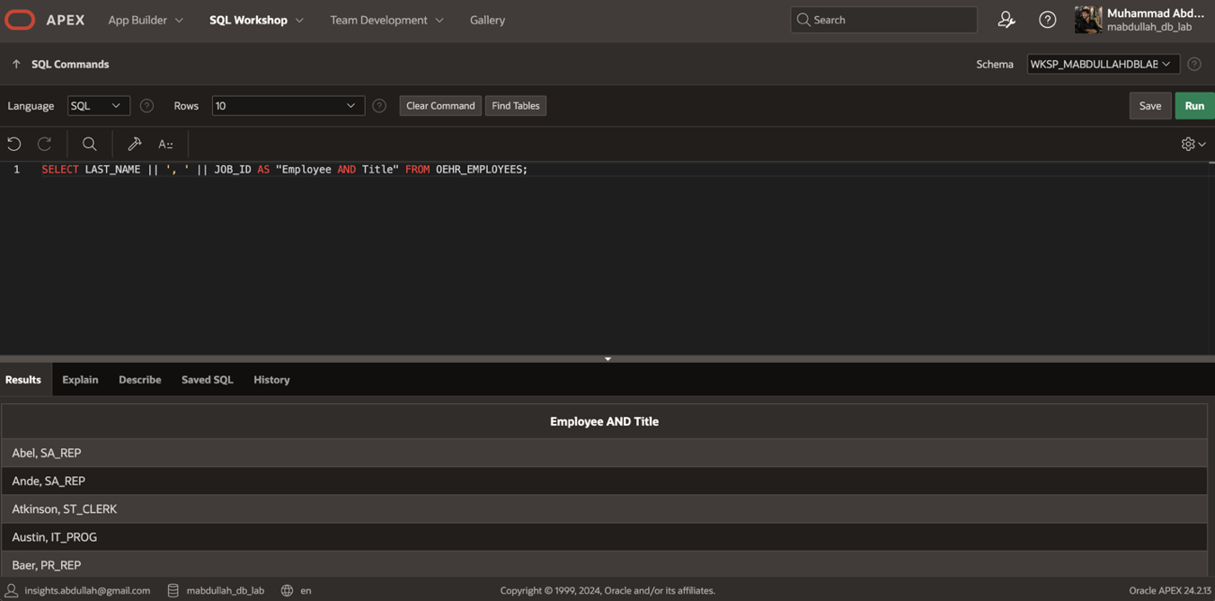
LAB TASK 3:
Write a SQL statement that instead of retrieving all rows from employees table for all job_id’s, find only distinct job_id’s.
Output:
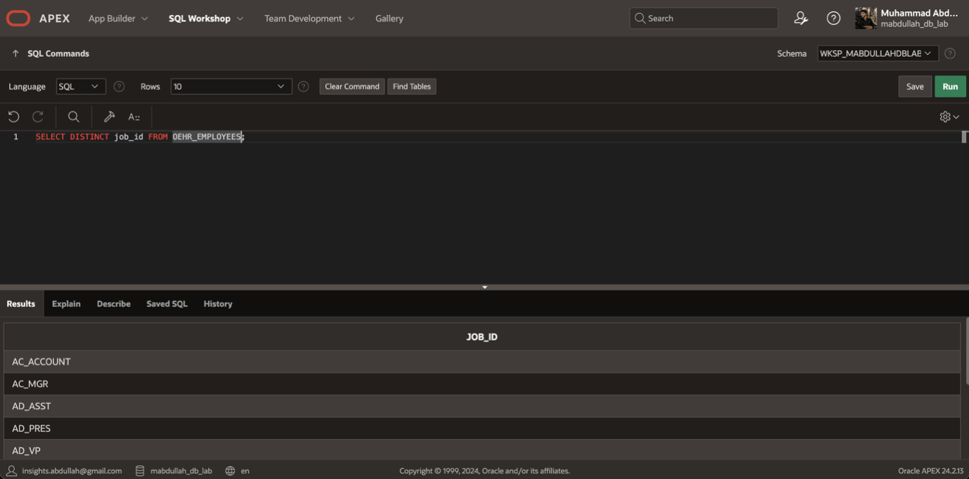
LAB TASK 4:
Write a SQL statement that shows first_name and last_name of all employee after concatenation them. Use space as the separator. Name the resultant column as “Name”
Output:
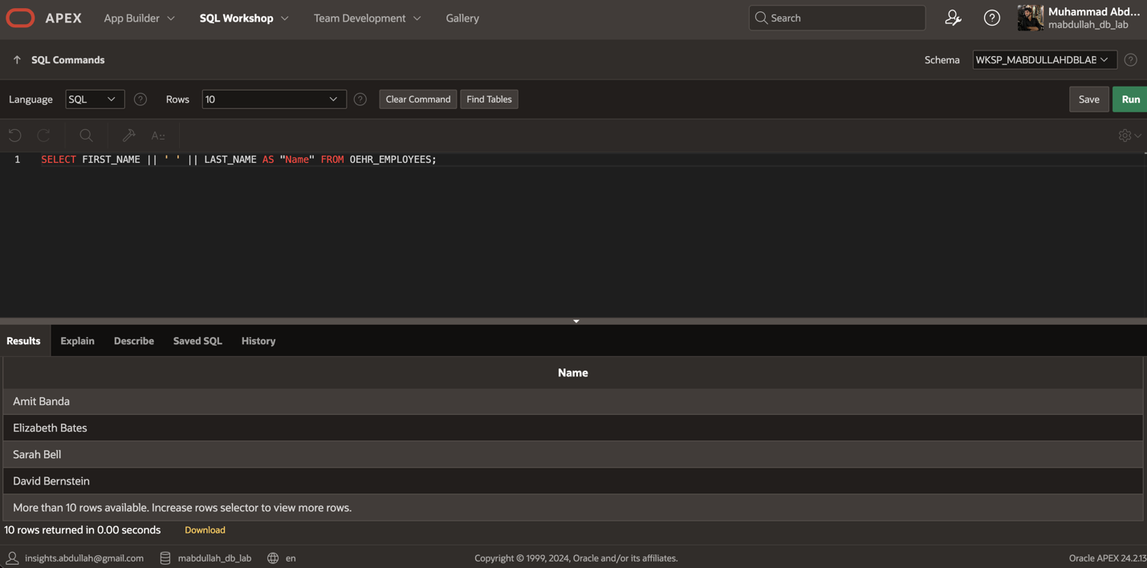
LAB TASK 5:
Write a SQL statement that displays first_name and the annual salary of employees.
Output:
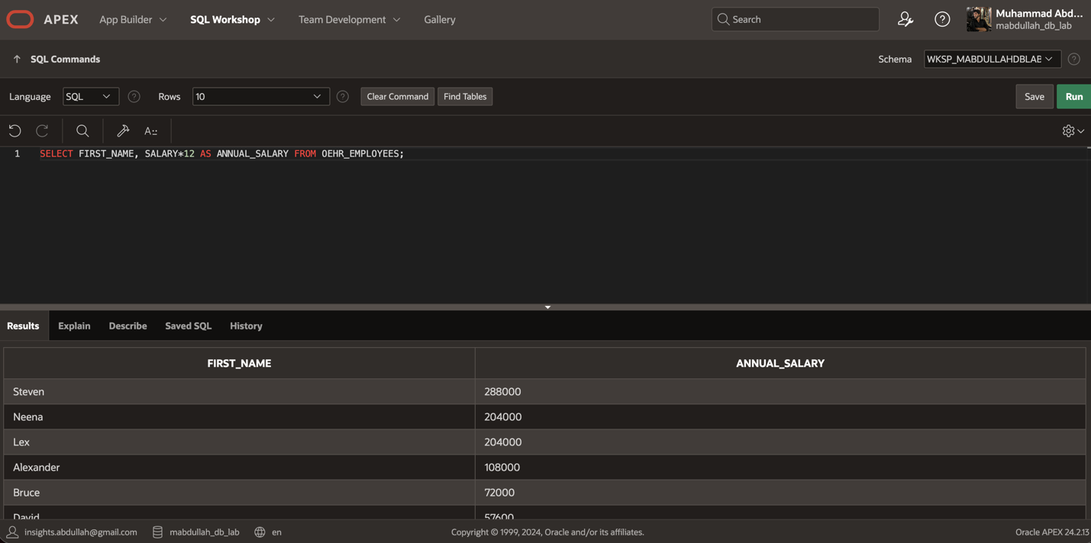
LAB TASK 6:
Write a SQL statement that displays the structure of the departments table.
Output:
